Properties and settingsto be used.
Insert your name and 087 credentails when required.
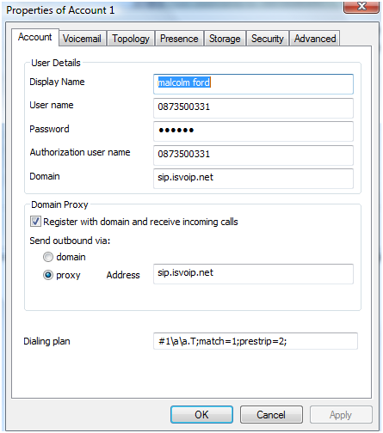
Under Options please make sure your settings are the same as below.

